BASKETBALL/NETBALL PLAYING IMAGES

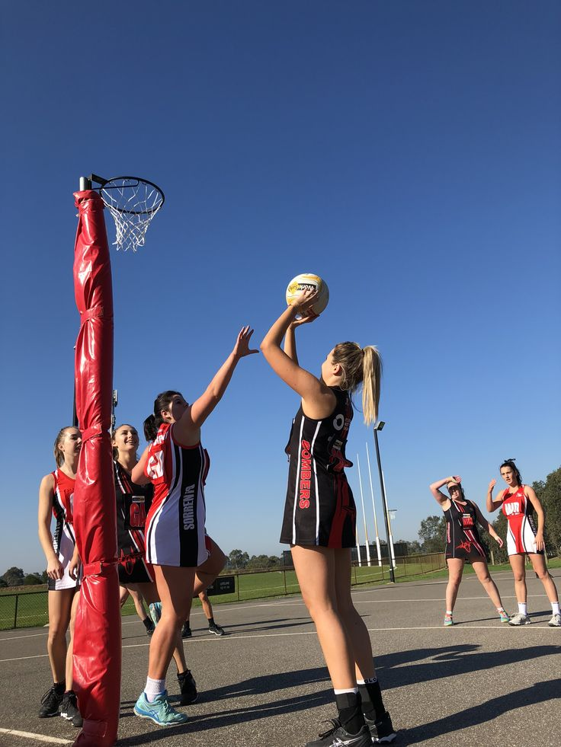

HANDBALL PLAYING IMAGES

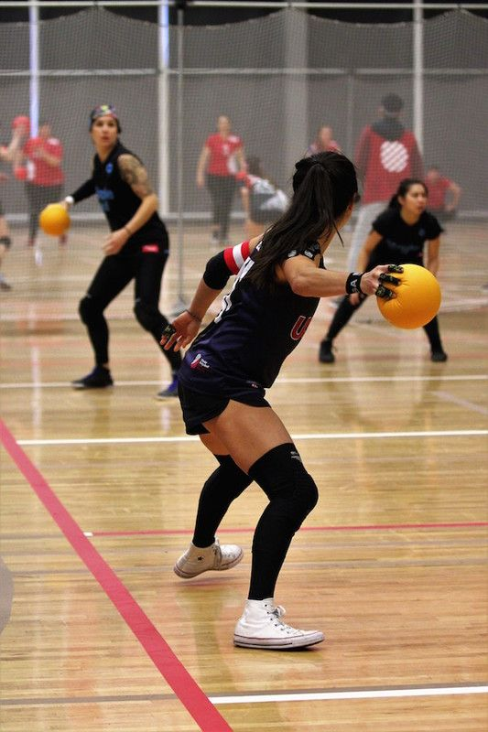

VOLLERBALL PLAYING IMAGES
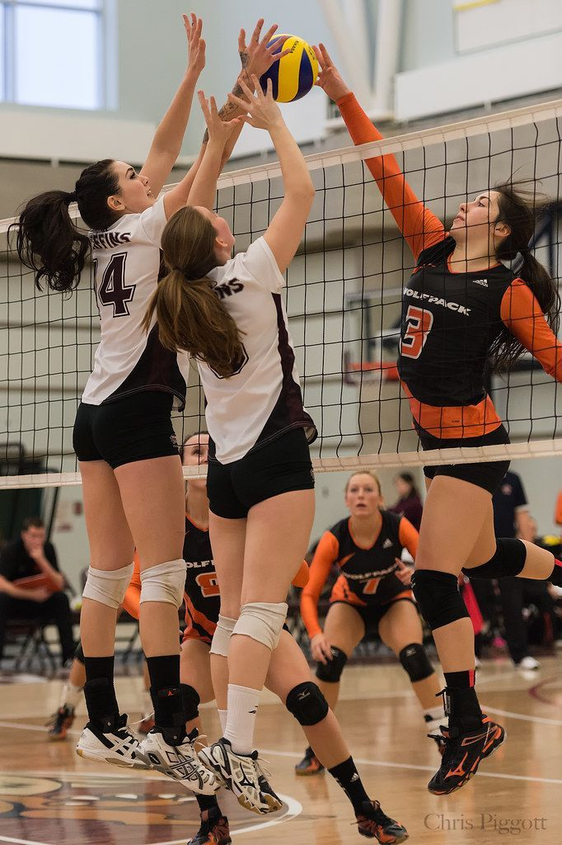

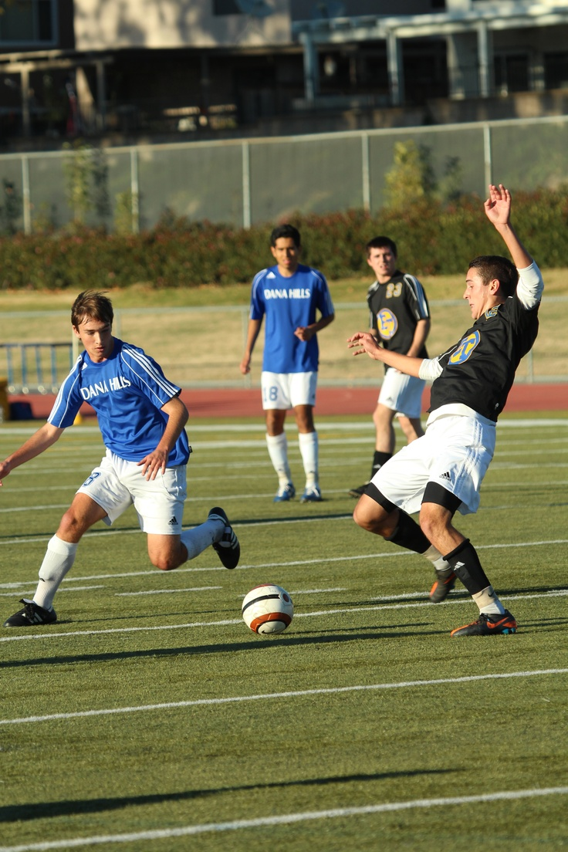
FOOTBALL PLAYING IMAGES

